

QA Manager Home Assignment
Introduction
At Solitics, AI is an integral part of our engineering process, including quality assurance. QA Managers are expected to use tools such as Cursor, ChatGPT, and GitHub Copilot to accelerate analysis, test design, automation, code review, and production investigations.
This assignment is not intended to test whether you can work without AI. It is designed to assess how effectively you combine AI with your own engineering judgment.
We are primarily evaluating your ability to:
- Understand complex distributed systems
- Prioritize engineering and production risks
- Design scalable QA processes
- Review and improve AI-generated output
- Make practical technical decisions
- Communicate clearly and concisely
Assume you are already the QA Manager responsible for this system.
AI Usage
You are encouraged to use AI throughout this assignment.
For each section where AI materially contributed, briefly describe:
- Which tool(s) you used
- What you asked AI to do
- Which parts of the output you accepted
- Which parts you modified or rejected
- How you validated the final result
We are not evaluating prompt-writing ability. We are evaluating your engineering judgment.
During the interview, you will be asked to explain your decisions and any AI-assisted work.
General Guidelines
- Prioritize quality over quantity.
- State assumptions when information is missing.
- Respect the answer limits.
- Diagrams and tables are welcome where they improve clarity.
- There is no single correct solution.
Please spend no more than four hours on this assignment.

System Overview
The following diagram represents a simplified version of Solitics' real-time campaign delivery system.

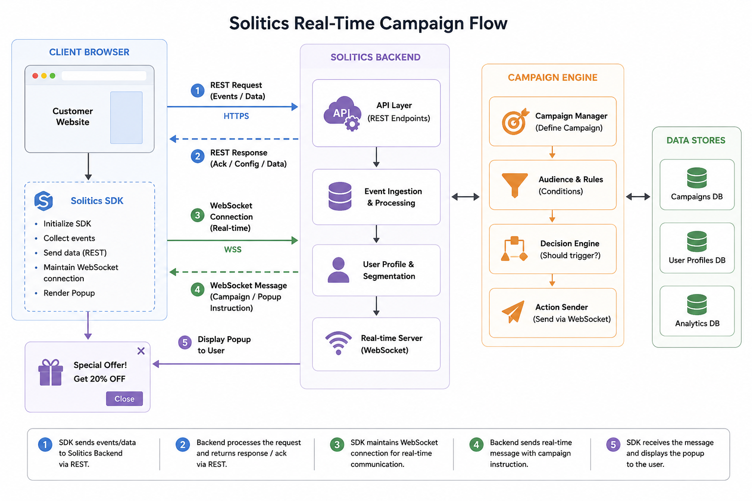

Part 1 – System Understanding & Risk-Based QA Strategy (25%)

1. Explain the System
Imagine a new QA engineer joins your team tomorrow.
Explain the system end-to-end.
Your explanation should include:
- The responsibility of each major component
- How data flows through the system
- Which interactions are synchronous vs. asynchronous
- The three highest-risk failure points in the architecture, and why
Limit: 500 words

2. Design the QA Strategy
Design a high-level QA strategy for this system.
For each test layer, explain:
- What it validates
- Why it exists
- Who should own it (developers, QA, or shared ownership)
Consider:
- Unit
- Integration
- API
- SDK / Browser
- WebSocket
- UI
- End-to-End
- Smoke
- Regression
- Performance
- Production Monitoring
Also describe:
- Which tests should run on every Pull Request
- Which before every release
- Which continuously in production
Limit: 700 words

3. Release Prioritization
Production has become unstable.
You have time to validate only three areas before releasing a hotfix.
For each area:
- What would you validate?
- What risk does it reduce?
- Why is it more important than the areas you did not choose?
Limit: 300 words

Part 2 – AI-Assisted Test Engineering (20%)

A developer asks AI to generate Playwright tests for popup delivery.

1. Write Your Initial Prompt
Write the prompt you would give an AI coding assistant.
Include:
- Relevant system context
- Expected behavior
- Edge cases
- Coding standards
- Assertion strategy
- Reliability expectations

2. Review the AI Output
The generated tests are flaky.
Describe:
- What likely caused the flakiness
- How you would improve your prompt
- What additional context you would provide
- How you would iteratively work with AI
- How you would decide the tests are ready for production
Limit: 600 words (excluding the prompt)

Part 3 – Code Review (20%)

The following Playwright test was generated by AI and submitted in a Pull Request.
test('Popup appears', async ({ page }) => {
await page.goto('https://demo.site');
await page.waitForTimeout(5000);

const popup = page.locator('#popup');

expect(await popup.isVisible()).toBeTruthy();

await popup.locator('.close').click();
});
Review the code as if you were reviewing a Pull Request.
Your answer should:

1. Identify the highest-risk issues
Prioritize the most important problems, such as:
- Reliability
- Flakiness
- Missing assertions
- Weak Playwright practices
- Missing edge cases
- Maintainability

2. Rewrite the test
- Rewrite it as production-quality Playwright code.
- State any assumptions you make.

3. Explain your improvements
- Explain the most important engineering decisions you made.

4. AI Validation
- Describe how you would validate the AI-generated code before approving the Pull Request.

Part 4 – QA Leadership & AI Strategy (20%)

You are joining Solitics as QA Manager.
The team consists of:
- 5 Backend Engineers
- 4 Frontend Engineers
- 2 QA Engineers
- 1 DevOps Engineer
The company uses:
- Claude
- ChatGPT
- BitBaucket
Design a high-level AI-first QA operating model.
Your answer should cover:
- Test ownership
- Pull Request validation
- Automated test generation
- Automated test review
- Smoke testing
- Regression testing
- Release validation
- Production monitoring
- Failure analysis
A workflow diagram is encouraged.

Human Judgment
Which QA activities should always require meaningful human review?
Explain:
- Where AI creates the greatest engineering risk
- Which decisions should never be delegated completely
- How you would prevent AI-generated defects from reaching production
Limit: One page (or equivalent diagram)

Part 5 – Production Incident Investigation (15%)

Yesterday afternoon, Marketing reported that popup delivery dropped from 98% to 67%.
Known facts:
- No deployments occurred
- Infrastructure is healthy
- API latency is normal
- No database alerts exist
- Only some customers are affected

Investigation
Describe your investigation.
Include:
- Your initial hypotheses
- The order of investigation
- Logs you would inspect
- Dashboards and metrics you would review
- How you would isolate the failing stage
- Which teams you would involve
- When you would escalate
Maximum: 10 ordered steps

Validation & Prevention
After identifying the root cause:
Explain:
- How you would confirm it
- How you would validate the fix
- How you would assess historical impact
- How you would prevent recurrence
Limit: 400 words

Submission

Please submit:
- Your answers
- Any diagrams or workflows
- A brief AI usage summary
Include:
- Which AI tools you used
- What you used them for
- Which outputs you challenged or rejected

